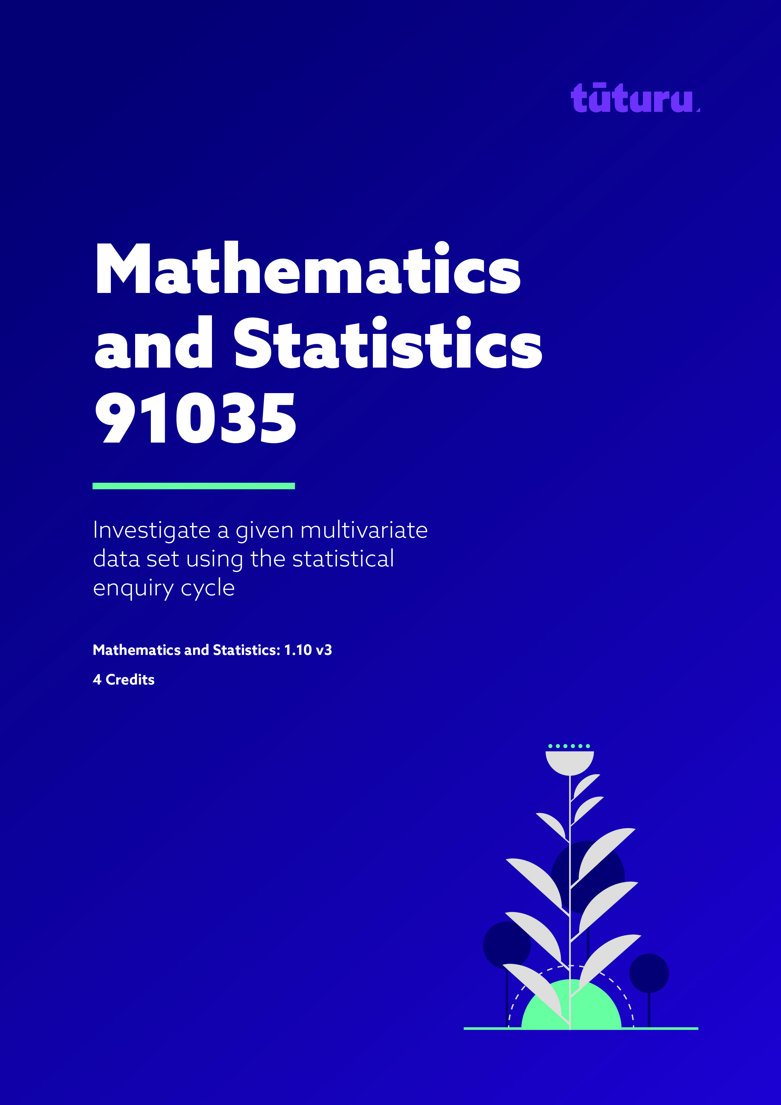
3157

Internal Assessment Resource
Achievement Standard Mathematics and Statistics 91035:
Investigate a given multivariate data set using the statistical enquiry cycle

Mathematics and Statistics: 1.10 v3

Credits: 4

Teacher guidelines
The following guidelines are designed to ensure that teachers can carry out valid and consistent assessment using this internal assessment resource. Teachers need to be very familiar with the outcome being assessed by Achievement Standard Mathematics and Statistics 91035. The achievement criteria and the explanatory notes contain information, definitions, and requirements that are crucial when interpreting the standard and assessing students against it.

Context/setting
This assessment activity involves students using the statistical enquiry cycle to make comparisons between groups within a given population. The context for this resource is a sample of students aged between 13 and 17 taken from a survey in 2012 from the Adolescent Health Research Group. The survey looked into the ‘wellbeing’ of these students, with a variety of questions asked.
Students were randomly selected using a two-stage cluster sample. Firstly, 125 schools were randomly selected from throughout New Zealand. Of the schools that opted into the survey, 20% of the students at the school were randomly selected. Overall, 2,996 students participated in the survey and their responses were collected. The population for this investigation is the ‘Participants of the New Zealand Youth Health and Well-being Survey 2012’. Students have been provided with a random sample of 200 students from within this population, to conduct their statistical investigation.

Conditions
This activity requires at least two separate sessions, likely more, and a possibility of independent work after the first two initial sessions. All work must be completed independently. It is important the teacher spends some time looking at the variables first in order for students to become more familiar with the context of the data provided. This may involve class and group discussions in the lead up to the assessment.
In the first session, students should use some time to pose two comparison investigative questions, while two questions are asked for, only one is needed for the actual investigation. This achievement standard requires students to compare a numerical variable across categories; a comparison of two category variables is not appropriate. Check students’ investigative questions and, if required, give students time to correct or improve them before they begin the investigation. If they are unable to produce at least one suitable investigative question, give feedback of a general nature indicating which of the question criteria have not been met; but do not provide them with a question. If more than minimal feedback is needed, the student is not ready for assessment against this standard.
The second (and subsequent) sessions are for students to carry out the analysis and write conclusions.

Resource requirements
There are two data sets to choose from available as spreadsheets in CSV format. They are samples of 200 students from the New Zealand Youth Health and Well-being Survey 2012.
Dataset A has the age (rounded down to the nearest whole number) of each student whilst Dataset B has the ages grouped into two groupings; ‘under 15 years old’ and ‘15 years old and over’.
You may provide students with a paper (Resource Sheet) copy of the data set for their analysis if they want one. Any technology is allowed for the analysis including but not limited to; calculator, Excel, Google Sheets and online statistical software such as NZ Grapher or iNZight.

NAME: | TEACHER:

DATE:

School Name

AS 91035 (v3)
Investigate a given multivariate data set using the statistical enquiry cycle
‘Student Wellbeing’

Authentication Signature - You are required to sign the authentication declaration below. If there is any doubt surrounding the validity of your research you will be interviewed.

I declare that all of the work and background research carried out in this assessment is my own.

Signed …………………………… (sign this when handing in your work)

Grade Acceptance for Achievement Standard 91035
(sign this after it has been marked)

Signed: ________________________________ Date: _________________
(Signature indicates sighting and acceptance of the grade awarded)

Achievement | Achievement with Merit | Achievement with Excellence
Investigate a given multivariate dataset using the statistical enquiry cycle. | Investigate a given multivariate dataset using the statistical enquiry cycle, with justification. | Investigate a given multivariate dataset using the statistical enquiry cycle, with statistical insight.
Overall level of performance

‘Student Wellbeing’
Mathematics and Statistics AS91035 (v3) Credits: 4

Achievement | Achievement with Merit | Achievement with Excellence
- Investigate a given multivariate dataset using the statistical enquiry cycle | - Investigate a given multivariate dataset using the statistical enquiry cycle, with justification | - Investigate a given multivariate dataset using the statistical enquiry cycle, with statistical insight
Student instruction sheet

Introduction
One of the largest studies looking into student well-being was conducted in New Zealand in 2012 by the Adolescent Health Research Group. The investigation has been named “The New Zealand Youth Health and Well-being Survey 2012”. After plenty of analysis the results have been made public recently and form the basis of this statistical investigation.

Policy-makers increasingly recognise that a society with healthy, vibrant and contributing young people is essential for future economic and social well-being (Little & Green 2009). Identifying and investing in the factors that contribute to young people’s well-being remains a significant area of enquiry.

Students were randomly selected using a two-stage cluster sample. Firstly, 125 schools were randomly selected from throughout New Zealand. Of the schools that opted into the survey, 20% of the students at the school were randomly selected. Overall, 2,996 students participated in the survey and their responses were collected. The population for this investigation is the ‘Participants of the New Zealand Youth Health and Well-being Survey 2012’. You have been provided with a random sample of 200 students from within this population, to conduct your statistical investigation.

The survey was administered using handheld tablets, allowing questions to be presented in an audio-visual form.

Task
Carry out an investigation of the dataset using the statistical enquiry cycle;

Problem:
- You have been given a sample of 200 responses from the population of ‘Participants of the New Zealand Youth Health and Well-being Survey 2012’. Pose two investigative questions that can be explored using this sample. Your investigative questions must be comparison questions. A suitable comparison investigative question is one that:
  - reflects the population
  - has a clear variable to investigate
  - compares the values of a continuous variable across different categories
  - can be answered with the data.
- For each question, state the variable you are investigating and the groups you are comparing. Now choose one of your two questions for your investigation.

Plan:
- Use the data provided and any information in the Introduction to help plan your statistical investigation.

Data:
- The data has been provided in a csv format, allowing technology to be used. A paper copy is provided if you prefer.

Analysis:
- Draw at least two appropriate graphs that show different features of the data in relation to your investigative question.
- Give appropriate summary statistics.
- Describe features of the distributions comparatively, for example, shape, middle 50%, shift, overlap, spread, unusual or interesting features.

Conclusion:
- Write a conclusion summarising your findings. The conclusion needs to include an informal inference in response to your investigative question and be supported with relevant evidence.

The quality of your discussion, reasoning, and how well you link this to the context of your investigation will determine your overall grade.

Resource Sheet: ‘Student Wellbeing’

The New Zealand Youth Health and Well-being Survey 2012 Dataset

Variable | Description
Gender | Male or Female
Age (years) | The age of the student rounded down to the closest whole year  13 (includes 13 and under), 14, 15, 16, 17 (includes 17 and over)
Wellbeing Score | This variable is the World Health Organisation-5 Wellbeing Intext (WHO-5).  Scores can range from between 0 to 25. The larger the WHO-5 score, the more likely they felt cheerful, calm, active, rested, and had things in their life that interested them over the previous two weeks.
Feelings | This variable is called the RADSSF score. Scores can range from between 10 and 40. The larger the RADSSF score, the more likely the student experienced low moods.
Challenges | This variable is the Total Difficulties Score from the Strengths and Difficulties Questionnaire. Scores can range from between 0 to 40. The larger the score, the more likely they had experienced social and emotional challenges over the past six months.
School Connection | This variable is the school connection score. Scores can range between 0 to 4. The larger the score, the more likely they had felt connected to their school.
Family Connection | This variable is the family connection score. Scores can range between 0 to 4. The larger the score, the more likely they had felt connected to their family.
Family Meals | This variable is the response to the question: “During the past 7 days, how many times did all, or most, of your family living in your house eat a meal together?”  Responses were given the following values:  Never = 1  1-2 times = 2  3-4 times = 3  5-6 times = 4  7 or more times = 5
Binge Drinking | This variable indicates that the student reported binge drinking once or more in the last month. Binge drinking was defined as 5 or more alcoholic drinks within a 4 hour period.  Not at all = 0  Once or more = 1

